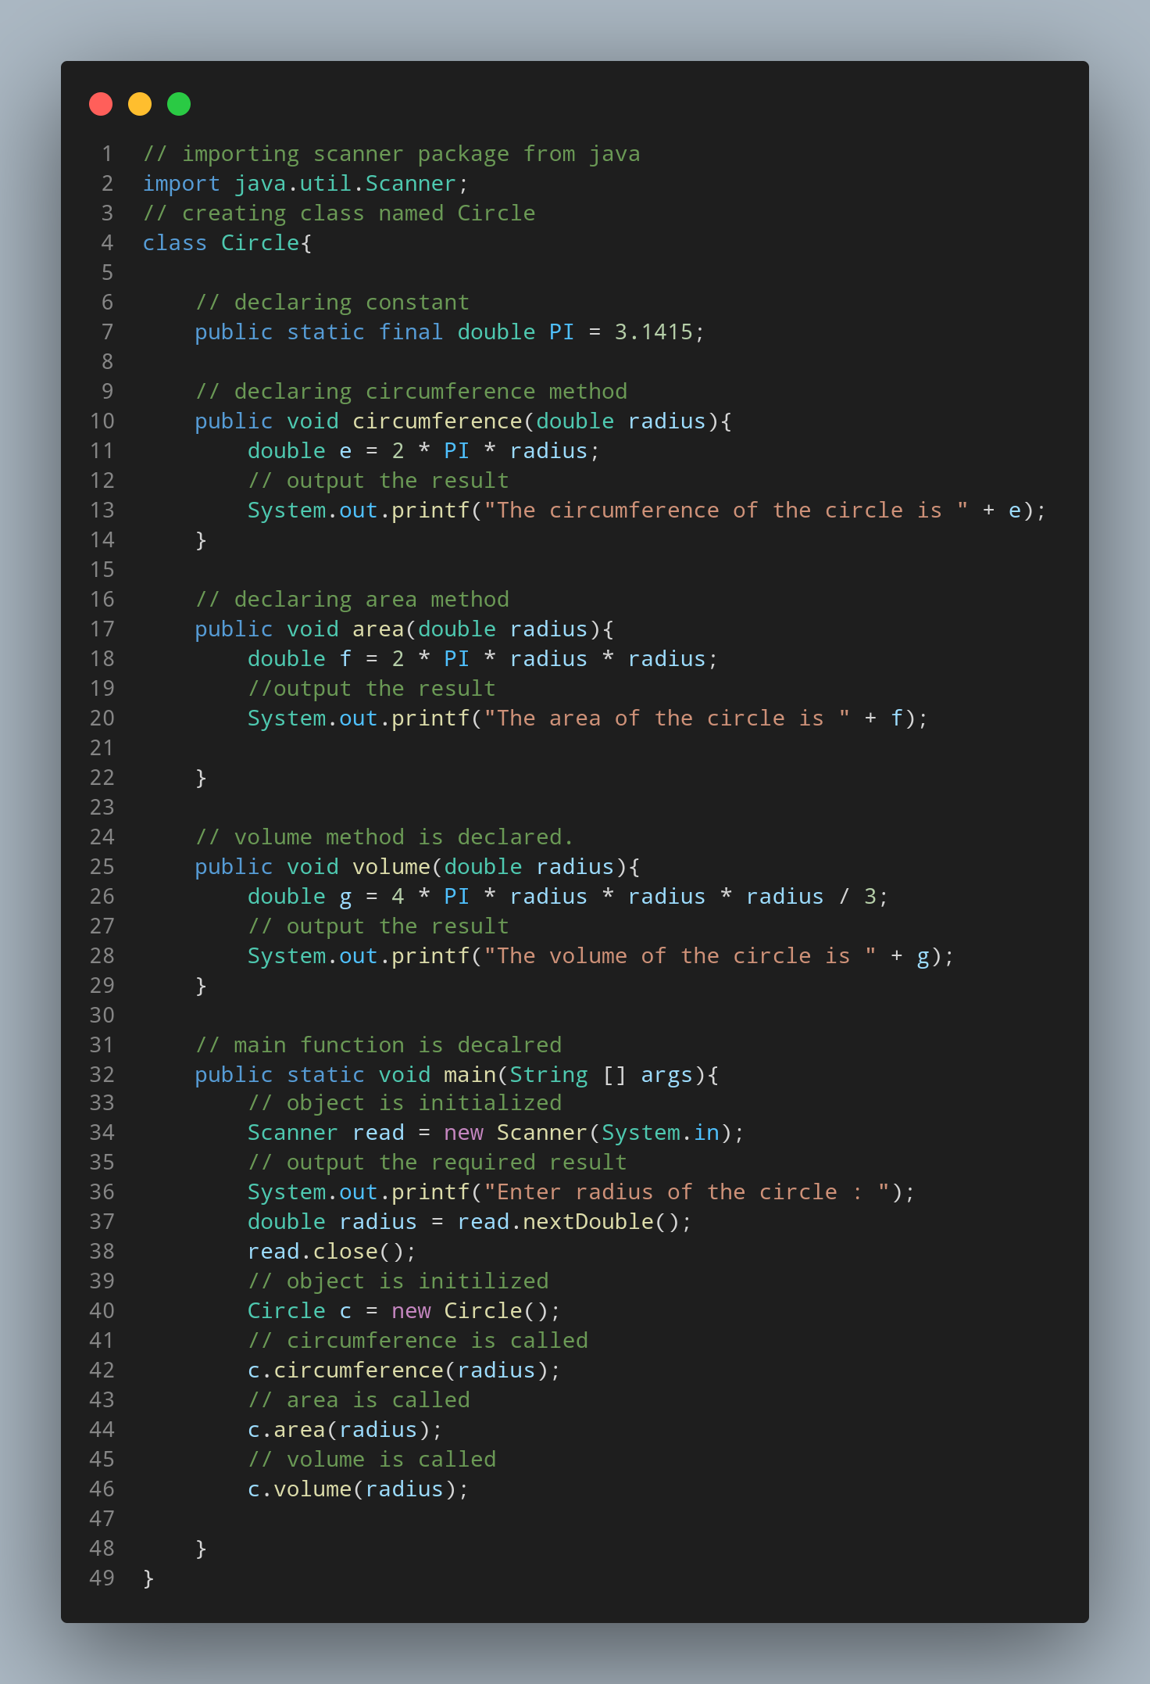

#Doc
java.util.Scanner is imported.
Circle is declared as class.
Constant PI declared with value 3.1415.
circumference method is declared.
Variable e of double data type is declared.
Code to output the result is written.
area method is declared.
Variable f of double data type is declared.
Code to output the result is written.
volume method is declared.
Variable g of double data type is declared.
Code to output the result is written.
Main method is declared.
Code to read the data entered from console is written.
Code to print the required output is written.
Code to read and assign a variable to the entered data is written.
Object is initialized.
Methods circumference, area and volume are invoked.

